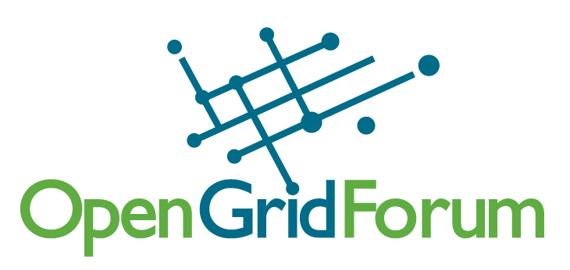
OGF19 PC Call Notes
11/30/06

Attendees:
Ann Collins
Alan Blatecky
Nate Klingenstein
Gwen Nichols-White
Geoffrey Fox
Steve Crumb
Ken Klingenstein
John Hurley
Robert Fogel
Cheryl Doninger
Joel Replogle
Craig Lee

- It was agreed that the PC would like to accept proposals that are more broadly involve the community as opposed to individual presentations or read-outs from a single organization’s work.

- 9 slots (eScience) will be reserved for the software developers sessions. Steve elaborated on the intention and history of this new addition.

Approved Proposals:
7) GIN-I: GIN and the HPC profile
8) GIN-II: GIN feedback to standards
5) Second Workshop on Reliability and Robustness in Grid Computing Systems
10A) SOA: What Do Users Need to Know? (One session)
11) Diversity Panel
15) Storage Networking Community Group (SN-CG)
19) Enterprise Grid Best Practices
23) Harmonization of the Management Specifications - an Overview
24) Workshop "Visualization on the Grid" (Two sessions)

- Next call Dec. 14th
- Joel will pull together draft schedule based on group requests and these approved sessions.

The PC has approved/declined the following. Notes and other actions are included below:
1) Title: Introduce: Graphical Creation of Globus Based Grid Services
DECLINE
2) The Application Service Grid -- SOA meets Grid Computing
DECLINE
3) Transactional Grids
DECLINE
4A) Secure Replication of Data in the Grid
DECLINE
4B) Secure Replication of Data in the Grid
DECLINE
5) Second Workshop on Reliability and Robustness in Grid Computing Systems
APPROVE
6) GRADIENT- Grid based Enterprise Data Integration Framework
This could have some interesting qualities. Can we some of the customers do the presentation? Infosys is basically a consulting company? Can this be sponsored by one of the community groups, built on top of OGSA-DAI? Can we converge this with the OGSA-DAI?
No Decision
7) GIN-I: GIN and the HPC profile
APPROVE
8) GIN-II: GIN feedback to standards
APPROVE
9) How to use benchmarks when evaluating new servers
DECLINE
10A) Title: SOA: What Do Users Need to Know?
The PC is concerned that this is a new effort, we’d rather have one session that’s successful.
APPROVE one session now.
10B) Title: SOA: What Do Users Need to Know?
DECLINE
11) Diversity Panel
Need to involve Stephanie.
APPROVE one session
12) CAOPS Discussion
Move to the Group Sessions
13) IGTF Discussion
Move to group session,
but if there’s Ad-hoc space available, we can give it to them. Don’t advertise as a community session.
14) Benefits of Service Processor Management in Grid Computing Environments
Don’t see the fit with our core audience.
DECLINE
15) Storage Networking Community Group (SN-CG)
Enthusiastic about trying to do this, panel session? John Hurley heading this up. Intention is to make this a standing session. Looks like a group session, if it’s going to be a panel, we’ll need a better agenda and abstract,
ACTION: John Hurley to get more info.
APPROVE
16) OGSA-DAI Data Access and Integration Technology Update
Plan A: Merge with this with the Software Development track.
Plan B: consider joining with the Gradient proposal.
17) IPR for grid Education and Training
The PC would like to see curricula developed. Why do they need 4 sessions?
Plan A: If there’s space within group sessions, they can do as many in there.
Plan B: In order to include this in the program, the PC would want something more relevant; more of a subject around developing curricula and the roadblocks around it.
ACTION: Geoffrey to send them mail regarding this and numbers 18 and 20.
18) Policies for cooperation on t-Infrastructure
Geoffrey action
19) Enterprise Grid Best Practices
Robert elaborated on the purpose of session: to brainstorm and the outcome would be ranked list of best practices. Call it a panel or a BoF, rewrite the abstract.
ACTION: Robert to refine and elaborate
APPROVE
20) Development of national and international Education and Training policy
Geoffrey action
21) Building End-User Applications for the Grid : Challenges and Opportunities. DILIGENT Early Lessons
Is this too narrow? Is there some breadth here? Title may be confusing. Would be interesting to have EGEE people involved. More interesting than if it’s just a DILIGENT presentation. Explain that we cannot have a session for every EU grid project, must be posed as a community program of some type.
DECLINE
22) Build, Test and Certification Community Group - Current practices and short term plans in building and testing Grid software
They had two BoFs, this is an initiation of a new group. Move them to group session.
23) Harmonization of the Management Specifications - an Overview
Web services convergence panel, will discuss work on specific topics. Only concern with this is that we need to place this at a time where it doesn’t conflict with standards activities. Would this work as a kick-off on Wednesday?
ACTION: Joel to bring this up at F2F, is this worth doing in plenary with standards guys? Or should it be a management area meeting?
APPROVED
24) (2 sessions) Workshop "Visualization on the Grid"
Broad enough, relates to data management too. Why are these particular people chosen? Can we ask them to put out a call, not sure there’s enough time between now and January. Concerned that it appears to not be the world community.
ACTION: Alan to advise Dieter to broaden.
APPROVED

